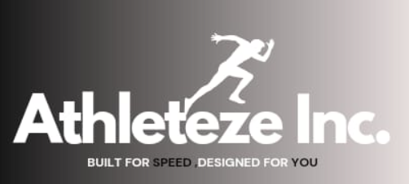

**Problem Statement:**

* **Environmental Impact: High carbon footprint associated with traditional textile manufacturing.**
* **Social Impact: Potential for fair labor practices and ethical sourcing.**
* **Economic Viability: Exploring sustainable materials**

**Solution:**

* **Sustainable Production: Utilizing eco-friendly materials and processes to minimize environmental impact.**
* **Ethical Sourcing: Prioritizing fair labor practices and responsible sourcing.**
* **Economic Viability: Developing a business model that is both profitable and sustainable.**

**Business Model:**

* **Product: Focus on sustainable and ethical clothing, potentially specializing in specific categories like shirts, t-shirts, jackets, sports bras, skirts, swimsuit, shorts and trousers.**
* **Concept: "Best Products, Best Price, Best Service"**
* **Target Audience: Eco-conscious and socially responsible consumers.**
* **Distribution Channels: Online platforms and physical stores.**

**Stakeholders:**

* **Customers: End-users of the clothing products.**
* **Manufacturers: Own product sourcing and manufacturing.**
* **Suppliers: Those providing other raw materials and components.**
* **Employees: Those working in production, manufacturing.**

**Opposition:**

* **Competition: Existing clothing brands, both traditional and sustainable.**
* **Supply Chain Challenges: Ensuring ethical and sustainable sourcing practices throughout the supply chain.**

**Budget:**

* **Initial Investment: Estimated at 250,000 INR.**
* **Timeframe: 13 months for initial setup and launch.**
* **Marketing Budget: 4,00,000 INR for various channels including social media, print ads, and influencer marketing.**

**Marketing Plan:**

* **Social Media Marketing: Utilizing platforms like Instagram and Facebook to reach target audience.**
* **Influencer Marketing: Collaborating with relevant influencers to promote the brand.**
* **Print Advertising: Placing ads in newspapers and magazines.**

**Sponsoring Events: Partnering with events that align with the brand's values.**

**Methodology:**

* **Research & Development: Exploring sustainable materials and production processes.**
* **Product Design & Development: Creating a line of clothing that meets the target market's needs and preferences.**
* **Supply Chain Management: Establishing a responsible and ethical supply chain.**
* **Marketing & Sales: Implementing the marketing plan to reach potential customers.**

**Reaching Customers:**

* **Online Channels: Shopify website, social media marketing, online advertising.**
* **Physical Stores: Potentially opening own stores at prime locations.**
* **Direct-to-Consumer Sales: Events, pop-up shops**